

CAPI 2.0 Proxy Linux Client Module:

By http://capi20proxy.sourceforge.net/

Warning: This module is not ready for use in any way. At least I managed once to load it into the kernel without killing it. It’s rather meant to let you folks give a general idea of what this could become...

Purpose:

This module provides a generic interface for user mode daemons that emulate CAPI 2.0 drivers.
It registers with kernelcapi as if it was a real (hardware) CAPI driver. On the other side it has a device node (/dev/capiproxy) as an interface for user mode daemons.
For every daemon opening /dev/capiproxy the module calls attach_ctr. That means each daemon is assigned a controllerId by kernelcapi. Messages from/to kernelcapi are sent via the read/write functions on the dev-node to user space.
Closing the dev-node makes the module call detach_ctr.
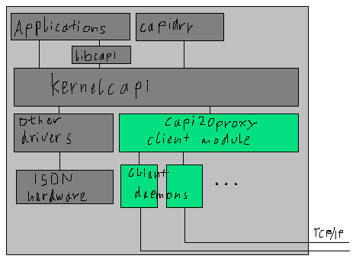
Spec for daemons:

- attaching:
opening the device node makes the module call attach_ctr. This creates a virtual controller which will be internally associated with the daemon that opened /dev/capiproxy
- initializing:
after attaching the module has to make a ioctl() call to the device node:
type: IOCTL_SETDATA
data: pointer to struct {
byte capi_manufacturer[CAPI_MANUFACTURER_LEN];
struct capi_version;
byte capi_serial[CAPI_SERIAL_LEN];
struct capi_profile;
};
This struct should be filled with data retrieved by calls to capi_get_xxx()
Only after this ioctl was successfully processed the module tells kernelcapi that the virtual controller is ready to receive messages
- registering applications:
When an application registers with kernelcapi each driver (or controller?) is sent a notification and kernelcapi waits for the driver to acknowledge the successfully registered application.
A notification is sent to the daemon by queuing a CAPI-style message in the associated controller’s message queue. This message has the COMMAND set to TYPE_PROXY and the SUBCOMMAND to TYPE_REGISTER_APP. The application identifier assigned by kernelcapi is stored in the APPID part of the message.
The daemon should retrieve this message using read() on the device node and register the application itself. (in the case of the capiproxy client daemon, the daemon will register the application on the server and will have to map application ids between module and server because the server will assign a different app_id to this app).
When the application was successfully registered the daemon has to do an ioctl() on the device node with type IOCTL_APPL_REGISTERED and the application id (the one kernelcapi assigned) in the parameter.
If the daemon fails registering the application it has to call IOCTL_ERROR_REGFAIL with the application identifier as parameter
- receiving messages:
The daemon should always poll the device node with read() calls. A buffer size of 10kByte should be more than sufficient.
Before forwarding or processing the messages the daemon has to adjust the controller identifier and the application identifier in the message.
Normally the messages received this way are CAPI messages. If they are CAPI_B3_DATA messages the data is appended just after CAPI message.
But also control-messages are sent via this method. These are indicated by the COMMAND set to TYPE_PROXY (= 0). The SUBCOMMAND defines the message type:
TYPE_REGISTER_APP: see above
TYPE_RELEASE_APP: like above (but releasing an application)
TYPE_SHUTDOWN: the daemon should immediately close the device node for the module is going to be unloaded. No messages can be received/sent anymore.
- sending messages to kernelcapi:
CAPI messages are sent to kernelcapi using the write() on the opened device node. The daemon has to set the application identifier to the message to the one known by the module/kernelcapi.

- detaching:
just closing the device node will make the module call detach_ctr and flush all message queues assigned to the associated controller

Installation:

Now this is not that easy. Newbies should not try!
- You could try to compile the capiproxy.h with the same options the kernel makefiles use to compile modules.
- copy capi20proxy.o to /lib/modules/2.4.*/kernel/drivers/isdn/
- depmod –a
- mknod /dev/capiproxy c 69 0

Reporting bugs & bugfixes & other comments:

Send any comments to the capi20proxy mailing list at
capi20proxy-public@lists.sourceforge.net
Especially when you make the module work on some platform/distribution!

If you want a daemon for some other LAN CAPI implementation please let us know!

Problems:

I have no clue about that interruptable_sleep & queue_task stuff.
The only way I made it work was to take all this out... can someone make it work with it?

TODO:

- debug this module
- write a configure script & Makefiles
- write daemons for LAN CAPIs (especially for capi20proxy!)

Please contact us if you are interested to do that!
We would appreciate any kind of contribution! :-)

Authors:

Begumisa Gerald M. (beg_g@eahd.or.ug)
Wrote most of the module

Adam Szalkowski (adam@szalkowski.de)
Wrote this doc & had idea to write module & corrected module & made it compile

